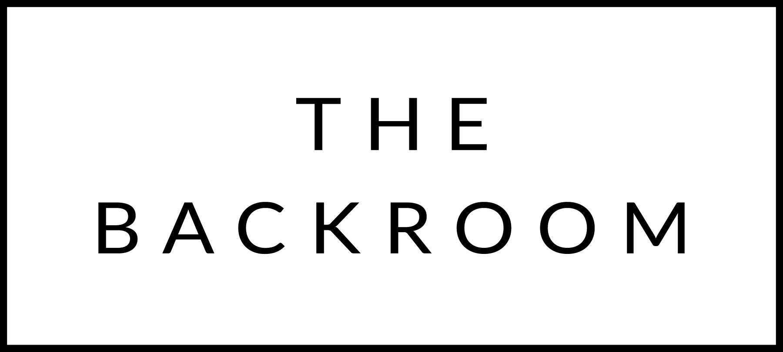

August 31st, 2015
Happy 60th Birthday

COCKTAIL HOUR SNACKS
Selection of Farmstead Cheeses
Malpeque Oysters & Shrimp Cocktail
Wasabi Aioli, Yuzu Cocktail, Mingnnette

FIRST COURSE
Tomato Carpaccio
Burrata, Husk Cherries, Garden Herbs
Raspberry Vinaigrette

THE MAIN EVENT
Boyden Farms Sirloin “Oscar”
Crab, Bearnaise & Potato Puree

FOR THE TABLE
Summer Bean Salad
Salsa Verde

DESSERT
Sweet Cream Pavlova
Blueberry Compote

