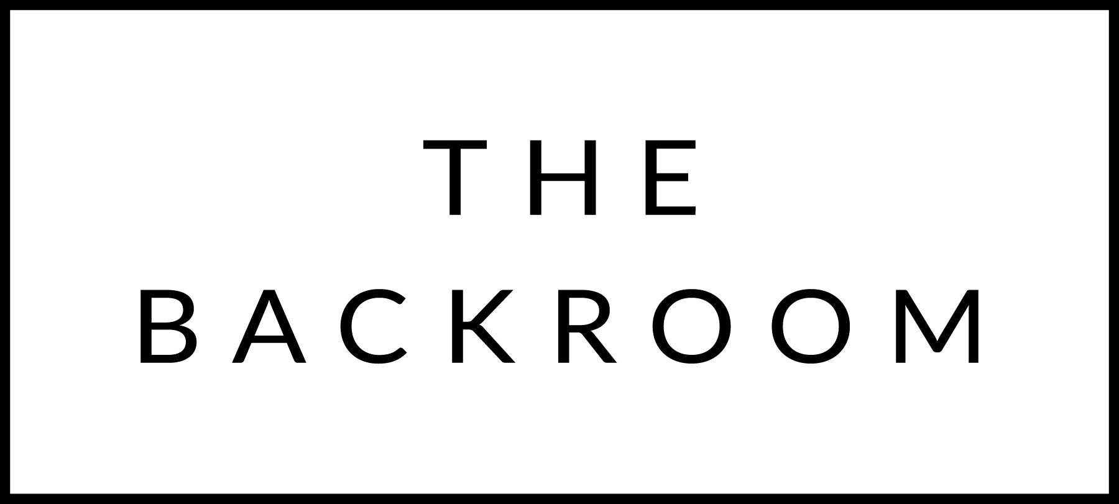

April 3 & 4, 2015

COCKTAIL HOUR SNACKS
Salmon Tartar
Wasabi Tobiko, White Soy & Yuzu

Market Vegetable Crudite
Tapenade & Hummus

FIRST
Tuscan Kale & Cranberry Bean Soup
Herb Puree

THE MAIN EVENT
Slow Roasted Farro Island Salmon
Bright Lights Chard, Farro & Beets
Buttermilk Dressing

FOR THE TABLE
Duck Fat Roasted Potatoes

DESSERT
Chocolate Cake
Gianduja, Whipped Cream

