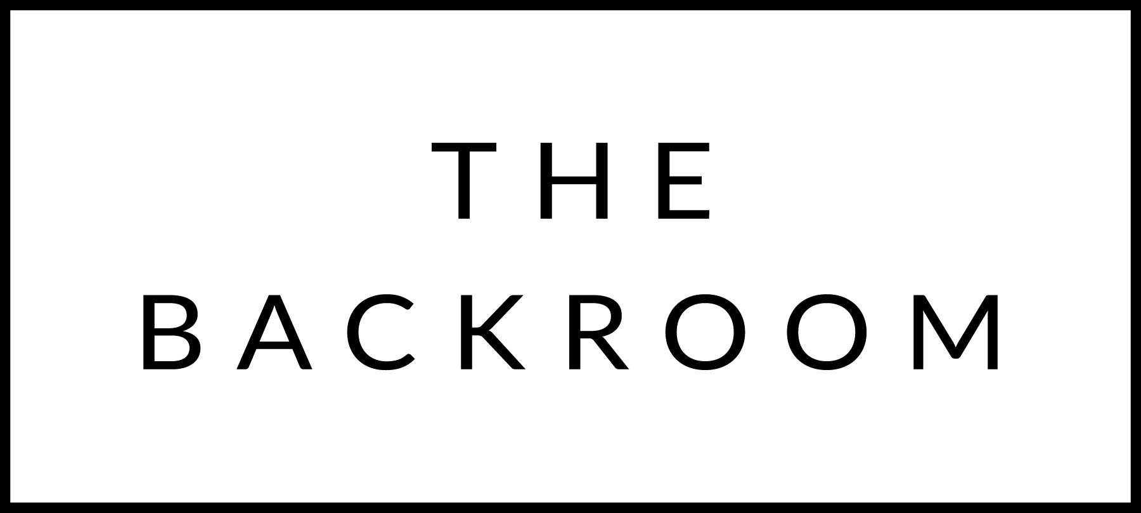

Abrams Family Brunch
November 27, 2015

BRUNCH

Buttermilk Biscuits
Maple Butter

Sweet Potato & Brussel Sprout Hash

Waffles
Whipped Cream & Cranberry-Blackerry Jam

Thanksgiving Leftover Casserole

Eggs Cocotte
Creamed Kale & Asparagus

Turkey & Cider Jelly Panini

Pumpkin Bread Pudding

