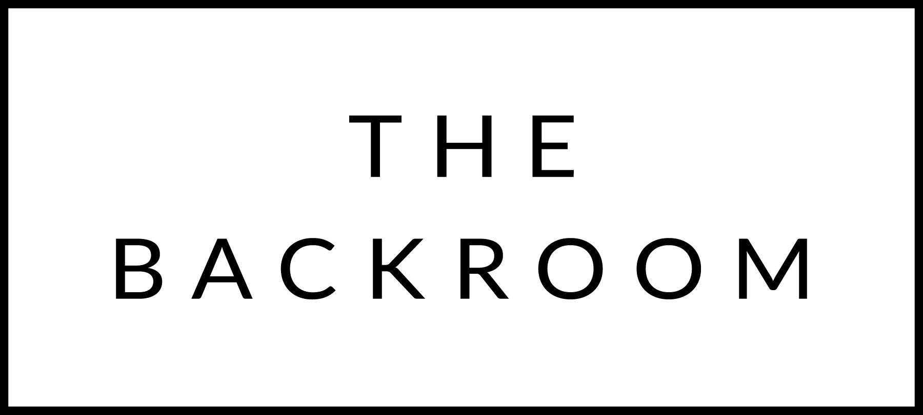

February 10th-12th, 2017

COCKTAIL HOUR SNACKS
Maplebrook Burrata, 25 year old Balsamic
Clothbound Cheddar, Maple & Coffee
Baked Brie, Wild Rhubarb Jam
Smoked Pimento Dip

FIRST
New England Clam Chowder
Sea Scallop, Housemade Bacon & Littleneck

THE MAIN EVENT
Farro Pizzichi Pasta
Lamb Shoulder, Dried Apricots
Olives & Herbs

FOR THE TABLE
Shaved Brussels Sprouts
Lingonberry Jam

DESSERT
Meyer Lemon Cheesecake
Candied Meyer Lemons, Chocolate Crust

