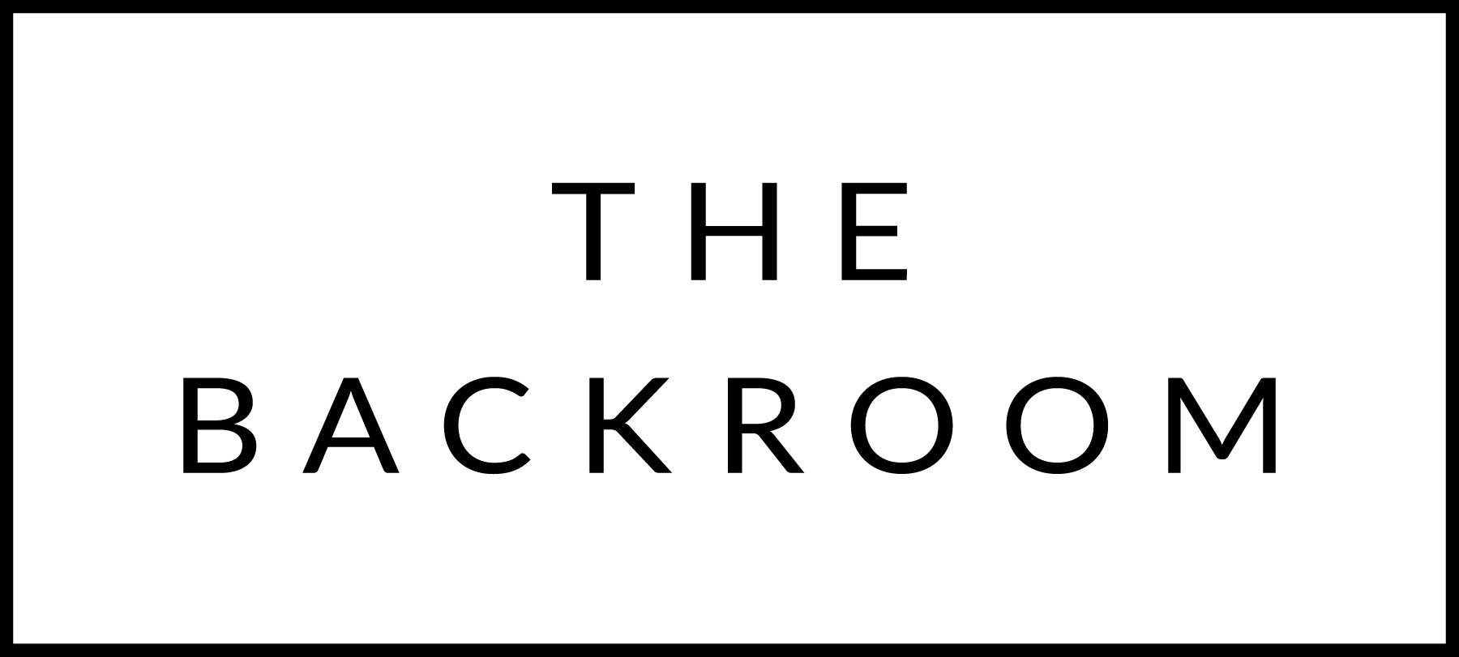

SPARKLING: in victory, you deserve it. In defeat, you need it. With dinner, it’s always a winner.

Gruet Brut, New Mexico, USA NV $40
A precise and bright sparkling with crisp acidity, complemented by a touch of yeast
Schramsburg Mirabelle Brut, North Coast, California NV $68
56% chardonnay and 44% pinot noir

A Margaine Cuvee Le Brut, Champagne, France NV $112
Lemony acidity and a finely detailed mousse

Pierre Gimonnet & Fils 1er Cru Brut Blanc de Blanc Cru Gastronome 2018 $159
Creamy and ample on the palate with terrific vibrancy underpinning the fruit

WHITE: we build from lighter and brighter to higher volume and heft

Karthauserhof “Bruno” Dry Riesling, Mosel, Germany 2019 $45
A thirst quencher with ripe fruit and bright acidity

Iapetus Antecedent Riesling, Shelburne, Vermont 2019 $70
100% riesling that’s super lean and high-toned

Patricia Green Sauvignon Blanc, Willamette Valley, Oregon 2021 $54
Willamette isn’t known for white wines, but this one proves it should be

Patrick Noel Sancerre, Loire Valley, France 2020 $68
A true taste of place in a glass

Albert Bichot Chablis, Burgundy, France 2021 $66
You’ll get green apples and a hint of citrus--it’s fresh and zesty

Maysara Arsheen Pinot Gris, McMinnville, Oregon 2019 $36
Biodynamic farming leads to a pure representation of Pinot Gris

Weingut Brand Weissburgunder, Pfalz, Germany 2021 $42
There’s an unexpected tension between crispness and roundness on the palate that’s captivating

Truchard Chardonnay, Carneros, California 2019 $60
100% barrel fermented in French oak, this is not your typical Napa Chard

Evening Land “Summum“ Chardonnay, Eola-Amity Hills, Oregon 2019 $96
A powerful and sophisticated chardonnay with warmth and balance

RED: the list evolves the same way your conversation at the table will—we keep it classy and light up front but get deep if you stick around

Anthill Farm Pinot Noir, Peterson Valley, California 2017 $94
Elegant, light bodied, and really good

Patz + Hall Pinot Noir, Carneros, California 2018 $89
At the crossroads of Napa and Sonoma, we get phenomenal Pinot Noir

Tenuta di Fessina Erse Etna Rosso, Sicily, Italy 2019 $50
70 year old vines in Volcanic soil, this field blend takes you to Mt. Etna

Fattoria Del Cerro Silineo Vino Nobile di Montepulciano, Tuscany, Italy 2018 $72
Primarily Sangiovese with a bit of Merlot and Corolino

Diego Curtaz Vallee D’Aoste Torrette, Aosta Valley, Italy 2019 $58
Only 208 cases of this Alpine red were produced

Jean Foillard Morgon Les Charmes Eponym Beaujolais, Burgundy, France 2020 $92
Sourced from the Charmes lieu-dit, one of Morgon’s highest parcels in the appellation

Saint Cosme Cotes du Rhone, Rhone, France 2020 $38
Dark inky Syrah to start, but integrated tannins kick in towards the end

Piedrasassi Syrah Patterson & Sebastiano, Santa Rita, California 2019 $90
Funky on the nose in all those brilliant cool-climate Syrah ways

Zorzal EGGO Tinto de Tiza Malbec Tupungato, Mendoza, Argentina 2017 $60
Great structure and body without any impression of weight

Omen Cabernet Sauvignon, Napa CA 2018 $42
Bold and powerful, but still approachable and balanced

Dash Cellars Zinfandel, Dry Creek Valley, California 2018 $42
Palate presents intense & vibrant red fruit with hints of chocolate and vanilla

Trig Point Diamond Dust Vineyard Merlot, Alexander Valley, California 2020 $54
Full-bodied and dense, the palate is lush with graceful tannins

Faust Cabernet Sauvignon, Paso Robles, California 2019 $104
Beautiful Napa Cabernet with fresh ripe fruit, good acidity and bold French oak

Gerardo Cesari Il Bosco Amarone della Valpolicella DOCG, Venice, Italy 2013 $125
Decadent and velvety, we’ve kept this on the list for years

