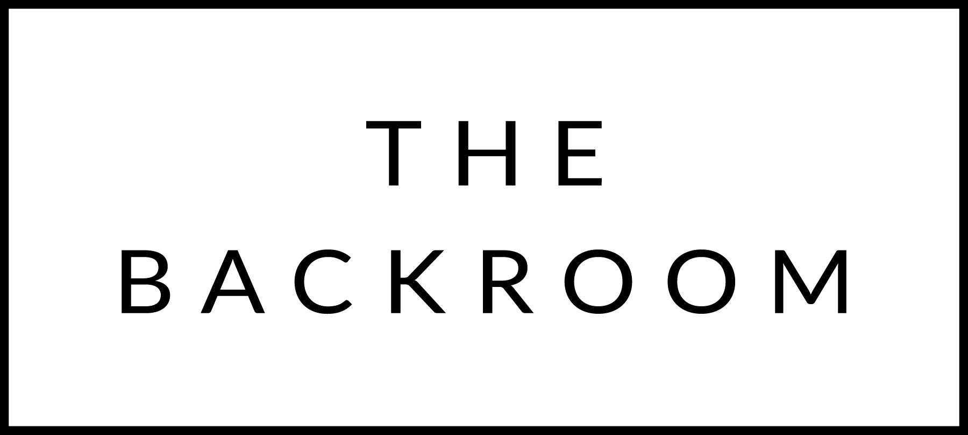

COCKTAIL HOUR SNACKS

Spring Brook Cheese Fondue
Broccoli, Potatoes, Summer Sausage
Gherkins

FIRST
Farro Pizzichi
Cabbage, Caraway, Creme Fraiche
Mustard Crumbs

THE MAIN EVENT
Roasted Misty Knoll Chicken
Coriander & Herb Brown Butter, Sweet Potato

FOR THE TABLE
Roasted Parsnips
Pomegranate Molasses & Seeds

DESSERT
Blood Orange Olive Oil Cake
Mascarpone Ice Cream

