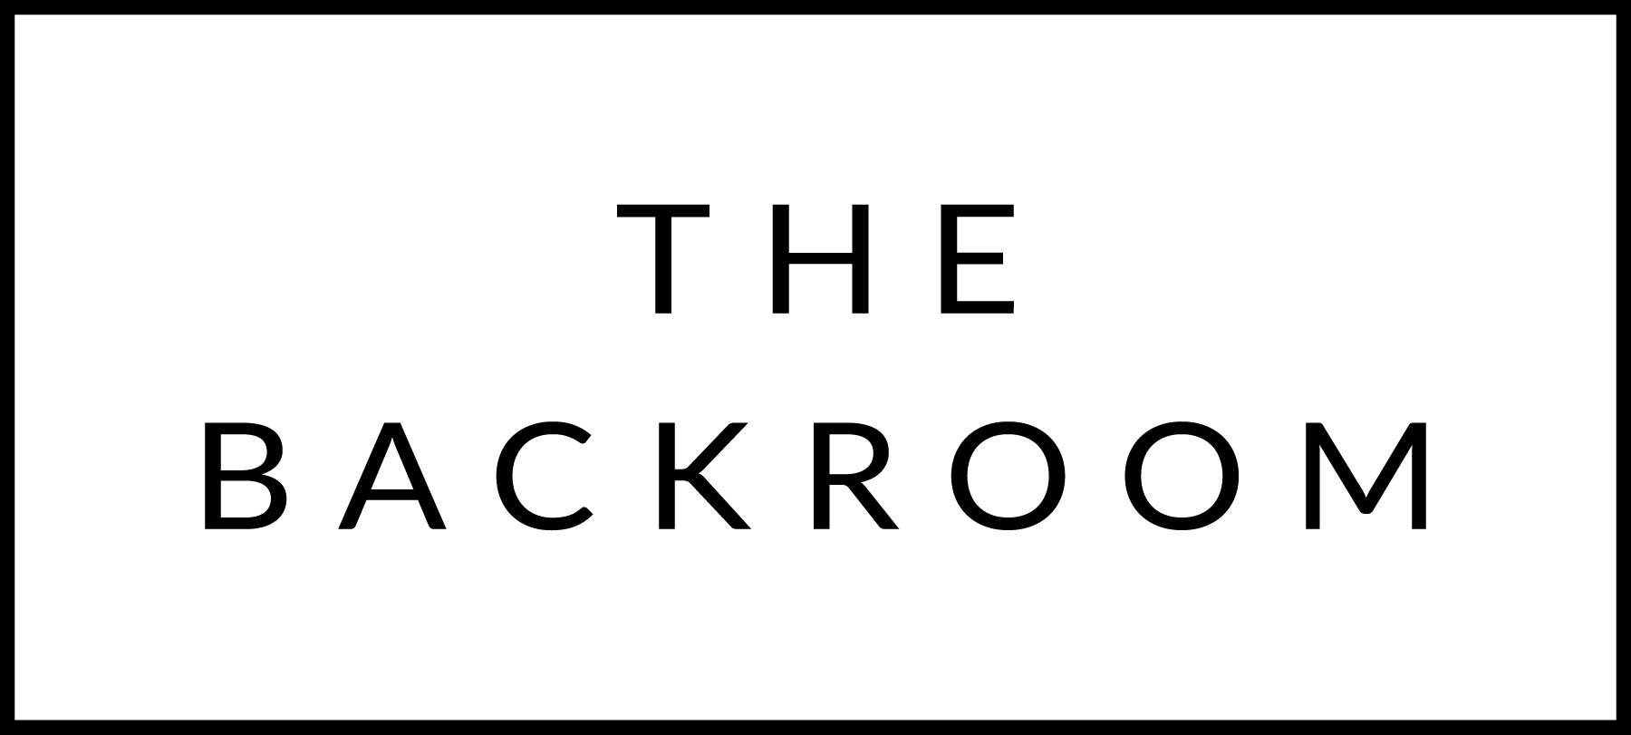

December 3rd, 2017

COCKTAIL HOUR SNACKS
Local Cheese & House Made Jams
Ricotta, Burrata, Bayley Hazen Blue & N’duja Cheddar

FIRST
Radiatori Pasta
Collards, Maitake Mushroom
Red Miso, Herb & Grain Crumbs

Failla Chardonnay, Sonoma, CA 2014
By the glass: $12, By the bottle: $58

THE MAIN EVENT
Smoked Local Short Rib
Kabocha Squash, Black Barley
Parsley-Tomatillo Jelly

Ravines Cabernet Franc, Finger Lakes, NY 2013
By the glass: $10, By the bottle: $45

FOR THE TABLE
Sauteed Spinach
Passionfruit Brown Butter

DESSERT
Earl Grey Panna Cotta
Polenta & Poppy Shortbread

