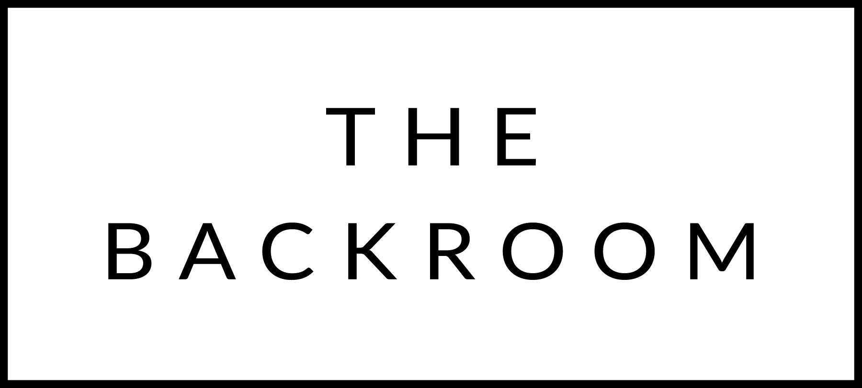

January 13th & 14th
Happy MLK Weekend!

COCKTAIL HOUR SNACKS
House Laffa Bread & Dips
Hummus, Blue Cheese & Sweet Potato, Pimento Cheese
Steak Tartar

TO START
Misty Knoll Chicken Pho
Thai Basil, Lime & Rice Noodles

THE MAIN EVENT
Red Wine Braised Shortribs
Celery Root & Portobellos

FOR THE TABLE
Lacinato Kale
Black Garlic Kimchi

DESSERT
Lemon Curd Tart
Shortbread & Marshmallow

