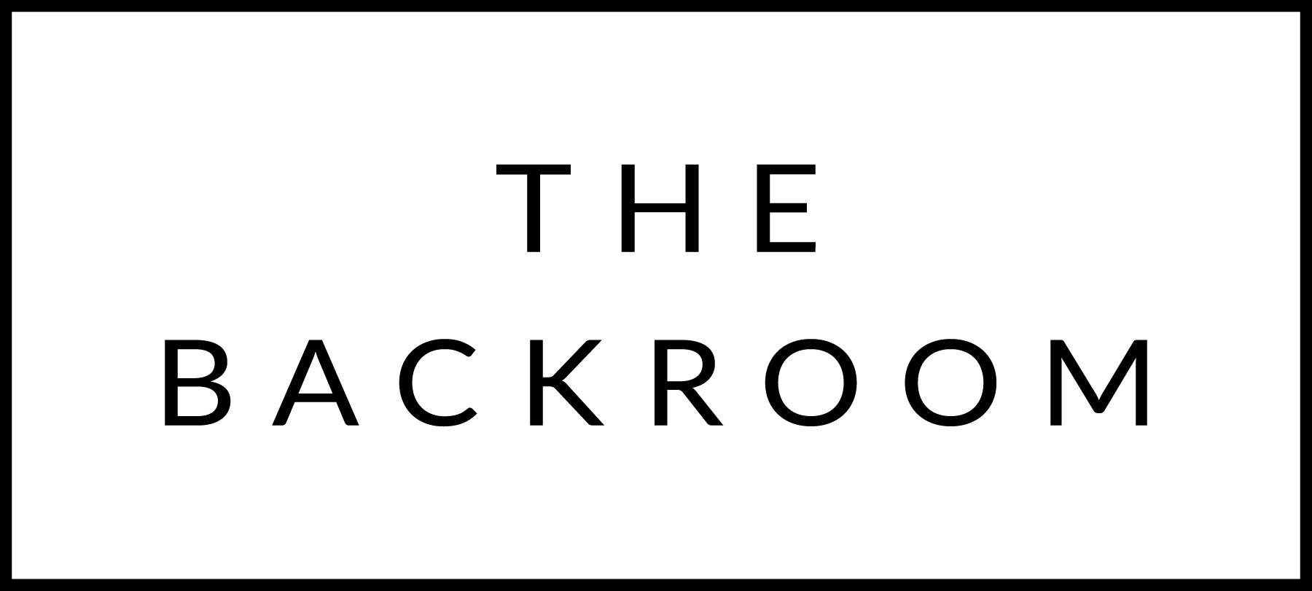

November 30th 2016
Sugar Bob’s Holiday Party!!!!!!

COCKTAIL HOUR SNACKS
Asian Steak Tartar
Cod Brandade, Tukey Liver Pater, Blue Cheese Mousse
Uni Toast

FIRST
North Country Bacon
Beluga Lentils, Pickled Ramps, Cabbage

THE MAIN EVENT
Misty Knoll Chicken
Mixed Drum Potatoes, Savory Granola
Hazelnut Jus

FOR THE TABLE
Roasted Brussels Sprouts
Housemde Kimchi

DESSERT
Kabocha Cake
Candied Squash, Brown Butter, Sage Ice Cream

