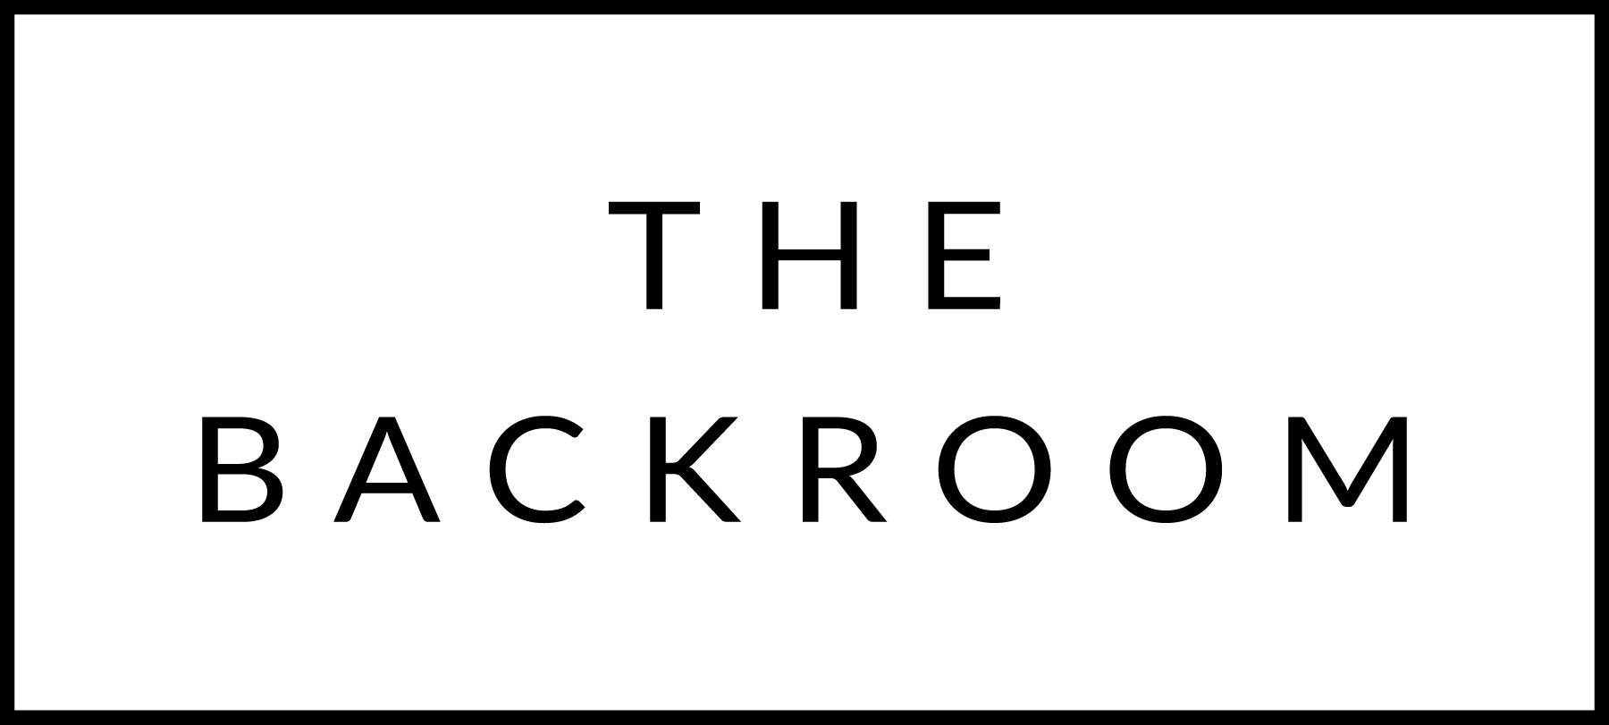

November 23rd-25th 2018

COCKTAIL HOUR SNACKS
Cheesy Potato Bites
Steak Tartar
Thanksgiving Sliders

FIRST
Matzo Ball Soup
Root Vegetables & Local Sausage

THE MAIN EVENT
Bacon Wrapped Filet Mignon
Sunchokes, Porcini & Black Garlic

FOR THE TABLE
Local Puntarella
Brown Butter, Anchovies & Vinegar

DESSERT
Flourless Chocolate Cake
Earl Grey Ice Cream, Crème Anglaise

